COVER LETTER FOR SUBMISSION OF MANUSCRIPT

July 16, 2019

Dear Molecular and Cellular Biomedical Science editor,

I am pleased to submit an original research article and I am enclosing here with a manuscript entitled “Isolation, Characterization, Proliferation and Differentiation of Synovial Membrane -Derived Mesenchymal Stem Cells (SM-MSCs) from Osteoarthritis Patients” submitted to Molecular and Cellular Biomedical Sciences for possible evaluation. We believe that this manuscript is appropriate for publication in Molecular and Cellular Biomedical Sciences. Our manuscript contributes for future studies in developing stem cells drug as therapy.
This manuscript has not been published and is not under consideration for publication elsewhere. The experimental protocol for this study was approved by the Ethics Committee of the Faculty of Medicine, Andalas University, West Sumatera, Indonesia. All the authors have directly approved the final version manuscript. We also have no conflicts of interest and hereby convey all copyright ownership exclusively to the journal.
Thank you for your consideration.

Sincerely,
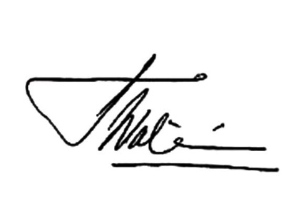
Dr. Wahyu Widowati, M.Si.
Faculty of Medicine, Maranatha Christian University

