SOYMILK FORMULA INCREASES ESTROGEN AND REDUCES TESTOSTERONE LEVEL IN MALE INFANT WHITE WISTAR RATS

Eveline Margo^{1*}, Wimpie I.Pangkahila², I Gusti Made Aman³

¹Department of Phisiology, Faculty of Medicine, Trisakti University, Jl. Kyai Tapa No. 260, Jakarta 11440, Indonesia
²Department of Andrology and Sexology, Faculty of Medicine, Udayana University, Denpasar, Bali, Indonesia
³Department of Pharmacology, Faculty of Medicine, Udayana University, Denpasar, Bali, Indonesia
*Corresponding author. E-mail: eveline_margo@yahoo.com

Telp: +62-5672731

METHODS
This research is an experimental research using post test only control group design conducted in Laboratory Animal Unit, Pharmacology Department Faculty of Medicine, University of Udayana, Denpasar, Bali from 22nd November 2015 until 06th February 2016. The sample consisted of 36 healthy male infant white Wistar rats aged 7 days, weighing from 10-15 grams, divided into two groups randomly, control group which is given cow’s milk formula for babies aged 0 – 6 months and intervention group which will be given soymilk formula for babies 0 – 6 months, and each groups’s intervention has a dose of 5% BW (gr).¹⁴ Administration was done twice a day orally for 21 days (in accordance with breastfeeding period).¹⁵ After the intervention, blood sample as much as 0,5 cc from the baby rats were taken in medial canthus sinus orbitalis of right eye, conducted in the morning to check the level of estrogen and testosterone. Examination level of estrogen and testosterone by used ELISA methods. Hormone level examination was conducted in UPT (Comprehensive Service Unit) Analytic Laboratory University of Udayana, Jimbaran Hill College. The data was analyzed using t-independent test.
ETHICAL CLEARANCE
The rats were handled according to the principles for animal experiments under control of the Commission for Medical Research Ethics, Faculty of Medicine, Udayana University, Denpasar, Bali.
TABLES AND FIGURES
Table 1
The Results of Normality Test of Estrogen dan Testosterone Data After Treatment
Subject Group | n | p | Information
Control Group Estrogen | 18 | 0.106 | Normal
Treatment Group Estrogen | 18 | 0.051 | Normal
Control Group Testosteron  Treatment Group Testosteron | 18  18 | 0.616  0.073 | normal  normal

Table 2
Data Homogeneity of Estrogen and Testosterone Between Groups
Variable | F | p | Information
Estrogen | 1.310 | 0.346 | Homogenous
Testosteron | 0.719 | 0.042 | Homogenous

Table 3
Difference of Estrogen Mean Between Groups After Administration of Cow’s Milk and Soymilk Formula
Subject group | N | Estrogen Mean (pg/ml) | SB | t | P
Control | 18 | 0.55 | 0.03 | 35.76 | 0.001
Treatment | 18 | 0.82 | 0.01 | 35.76 | 0.001

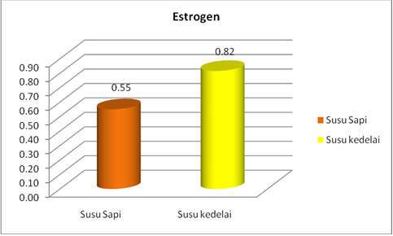
Soymilk Formula

Cow’s Milk

Soymilk Formula

p = 0.001

Cow’s Milk

Figure 1. Difference of Estrogen Mean Between Groups After Administration of Cow’s Milk and Soymilk Formula

Table 4
Difference of Testosterone Mean Between Groups After Administration of Cow’s Milk and Soymilk Formula
Subject group | N | Testosterone Mean (mg/ml) | SB | t | P
Control | 18 | 3.25 | 0.15 | 14.32 | 0.001
Treatment | 18 | 2.36 | 0.22 | 14.32 | 0.001

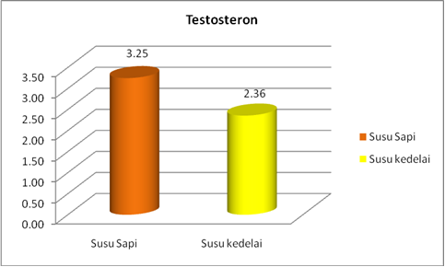
p = 0.001
Soymilk Formula
Cow’s Milk
Soymilk Formula
Cow’s Milk
Figure 2. Difference of Testosterone Mean Between Groups After Administration of Cow’s Milk and Soymilk Formula

