COVER LETTER FOR SUBMISSION OF MANUSCRIPT

April 15, 2019

Dear Editor,

I am pleased to submit an original research article and I am enclosing here with a manuscript entitled “Antioxidant Activities of Ficus elastica Leaves Ethanol Extract and Its Compounds” submitted to Molecular and Cellular Biomedical Sciences Journal for possible evaluation.
This manuscript has not been published and is not under consideration for publication elsewhere. All the authors have directly approved the final version manuscript. We also no have conflicts of interest in this study.
Thank you for your consideration.

Sincerely,

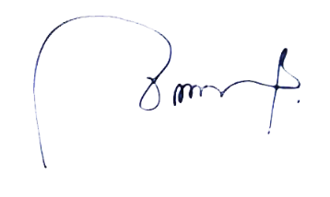
dr. Chrismis Novalinda Ginting
Faculty of Medicine, Universitas Prima Indonesia

